Training and participation of our children in democratically elected, self-governance system known as Children’s Parliament
“Leader is one who knows the way, goes the way, and shows the way” - John C. Maxwell
Introduction:
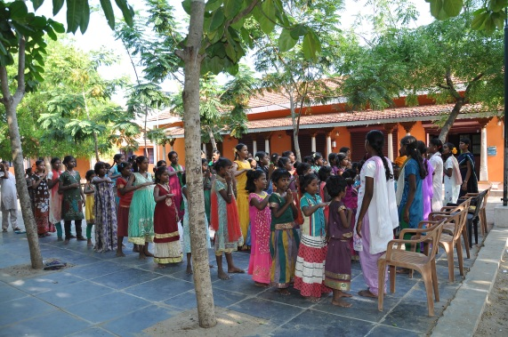
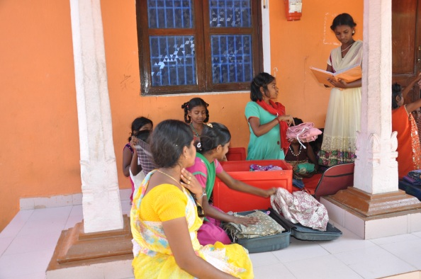
India is known for its Democracy when it is politically seen. The people of the nation are given full freedom to choose their own leaders and own the country. In India, politics has become another field of acquiring wealth and fame in real quick time. In the recent past even cine actors have started their own party and entered into politics. It is very obvious in our state, Tamilnadu. Often time people of Tamilnadu vote for their favourite actors because they him/her. They fail to assess the quality of leadership, his/her real interest. We had some real leaders few decades ago like Kamarajar. But these days politics is filled with self-proclaiming and seldom work towards betterment of people. In these circumstances it is very important and vital that the children, at present, will be the pillars of the nation or state and need to know that they have to use their voting power to choose the right leader. Instead of being taken by whims and fancies, they need asses the leader, their quality, character and motivation to get into politics. To educate the children in this regard and make them know their rights we have this practice called Children’s Parliament and this write up will give you glimpse of this program’s purpose, impact, process.
Purpose:
Every activity which is organized for children is aimed at imparting some values and knowledge in the children.
- Making the children aware of their rights of voting
- Making the children to choose the leaders wisely, not to be taken by whims and fancies.
- Giving chances for the children to lead the group
- Making the children to act without any disparities.
Process of Implementations:
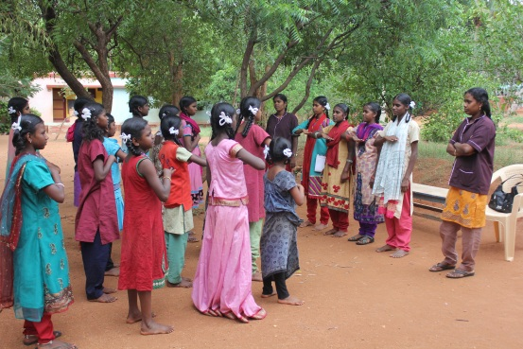
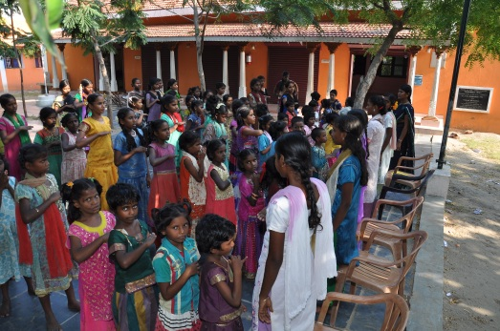
The members of the ruling group are chosen by secret ballot. This chosen group can form a parliament or Panchayat or any suitable grouping for children who will be responsible as much as of the running of the “Home” as is completely possible. The ones actually in-charge must be ready to step back and remain on the fringe and to interfere as little as possible once the system is running smoothly. It is sometimes quicker to deal directly with a need or a matter of discipline or a job to be done rather than to go through the ones among the girls in-charge, but how much more rewarding in the long run is the later, how much more educative in the best sense, than for the child to be told all the time what to do and how. It is very essential that the ones in-charge must be ready to help and guide, but neither to dominate nor misuse the power given to them. The results of the method are astounding and can only be learned by experience and experimenting too. One will quickly find that general discipline improves considerably and that the ones in-charge truly become a leader figure they should be and not the repressive and feared overlords. The wardens can relate in a much better way with the children in their care. The children themselves learn to accept responsibility and to supervise and guide the younger ones or the weaker ones. The children learn to stand on their own feet and make their own decisions and arrive at a community decision in policy making. But the system must eventually filter right down through the whole lives of the people living together in Hostels.
Those responsible for the whole set up must all the time try to see how the system can more and more be used and influence the lives of the children, the small democracy children’s home should be. And the definition of democracy is,
“Government by people (In this case children) as a whole especially through elected representatives” –Oxford Dictionary
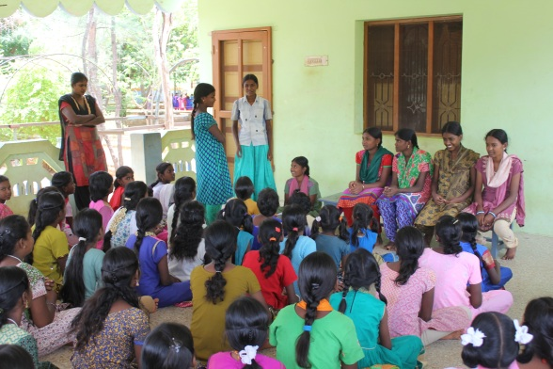
And the definition is complete for those who wish to introduce this system into their areas of work with children. We have been living with this system for the past quite few years and would not ever revert to the traditional barracks system of caring for girls. We are convinced that the system must be allowed to function to its fullest degree and not be introduced only in part or with too much domination from adults.
Impact:
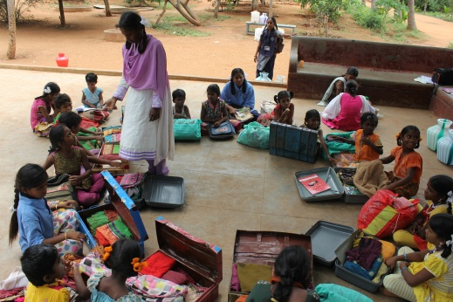
When we have this practice for many years, the children begin to understand their rights. They feel that they have responsibilities in choosing their own leader. They children could foresee much greater task ahead once they enter into the public life. They come to know the standards to evaluate a person who wants to be leader for a public group and constituency, state or the nation. They also become aware of how a bad leadership could cause havoc in their life. Naturally the children begin assess their leaders before making them take the position. This practice is indeed of great idea for the children to face the public life and improve their conscience in selecting their leaders.

Conclusion:
We are very much glad that we give every child an overall development. It is not education alone makes a student a better citizen but it is through making them aware of the society in which they are going to live. We could really see the difference in the children who have passed out from our institute in the past years. They have shared how this practice has yielded fruit in their lives. We are so pleased to present you this short report about this particular program carried out in our institutes.
